Univertical Practice Quiz

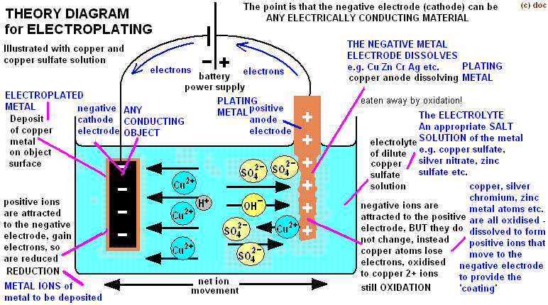

We want to electroplate a coin with copper on both sides to a depth of 1 micron thick in 5 minutes.  The diameter of the coin is 0.955 inches.  The electrolytic solution that is being used is copper sulfate.  Faradays constant is 96 485 C/mol.  Copper has a specific gravity of 8.78 and a molar mass of 63.5.  An Amp is a Coulomb /s.  Assume the coin is very thin so the amount of coating on the edge of the coin is negligible

1. How many milli-moles of copper should be deposited?
2. How much average current (in milli-Amps) should be used?

